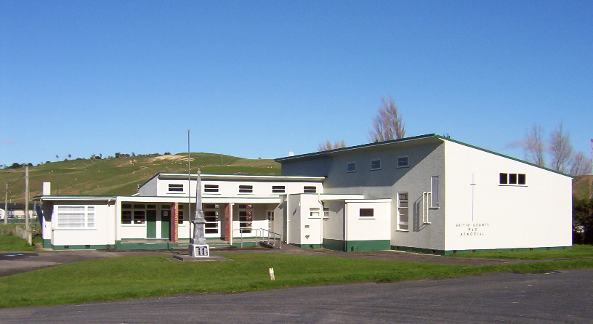
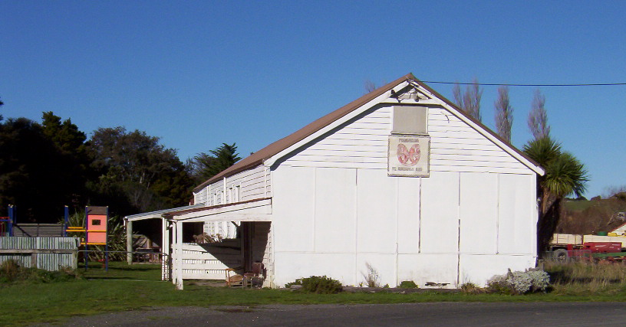
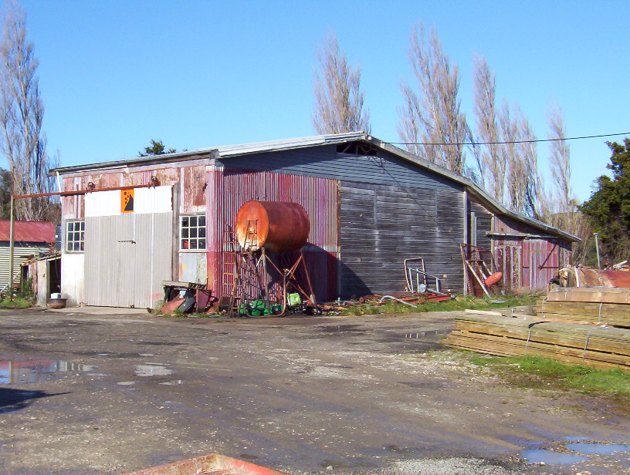
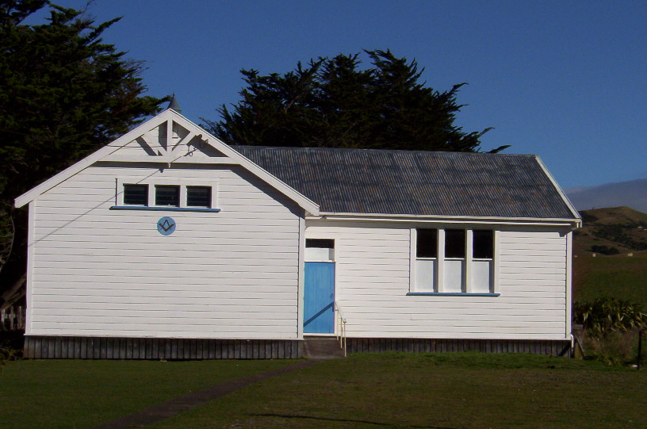
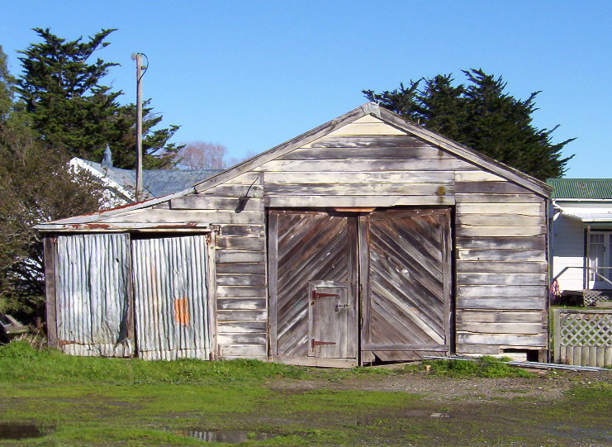
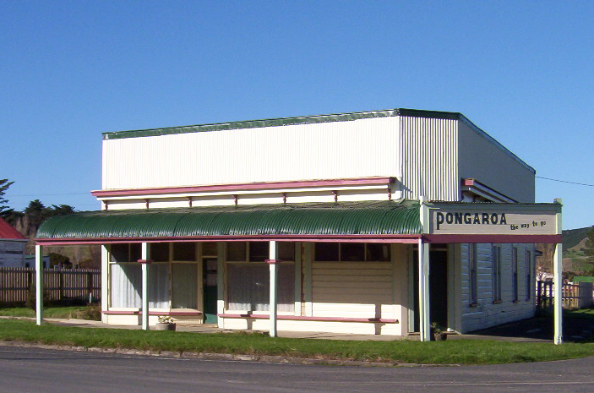
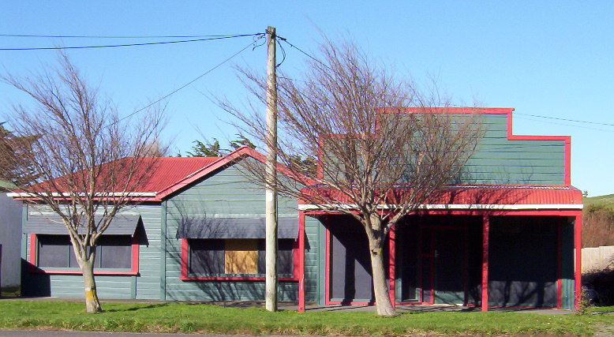
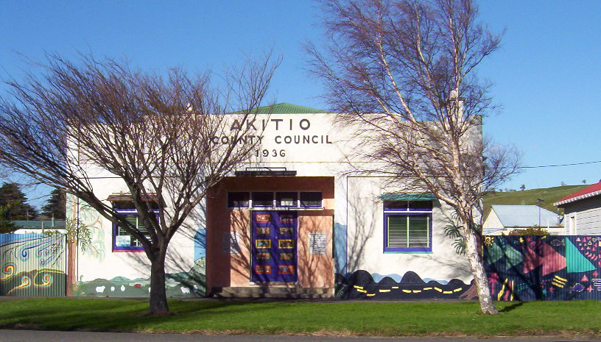
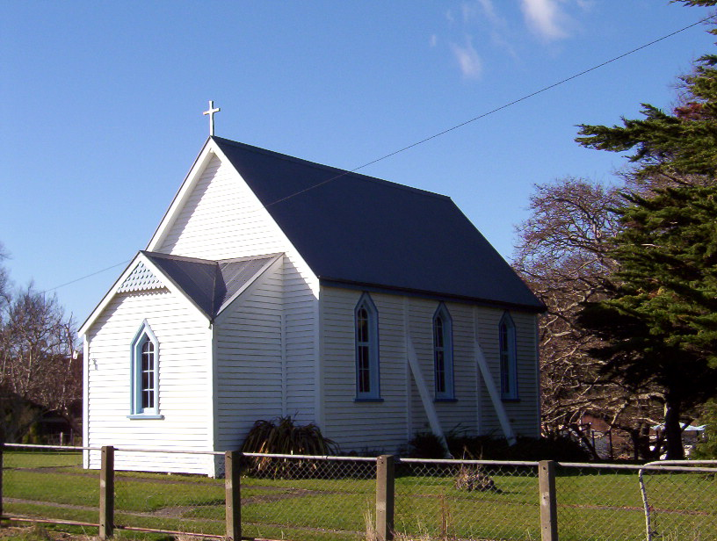
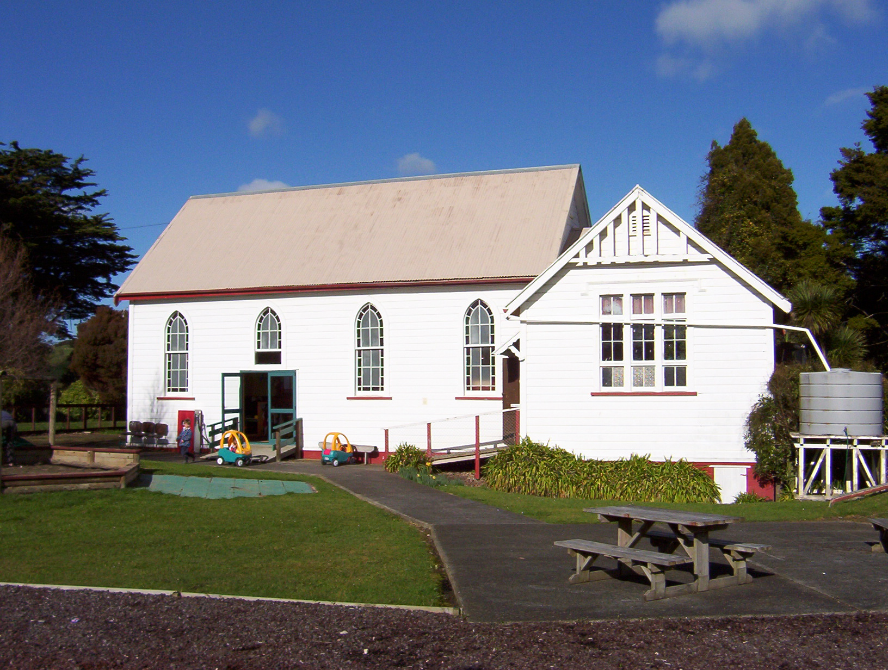
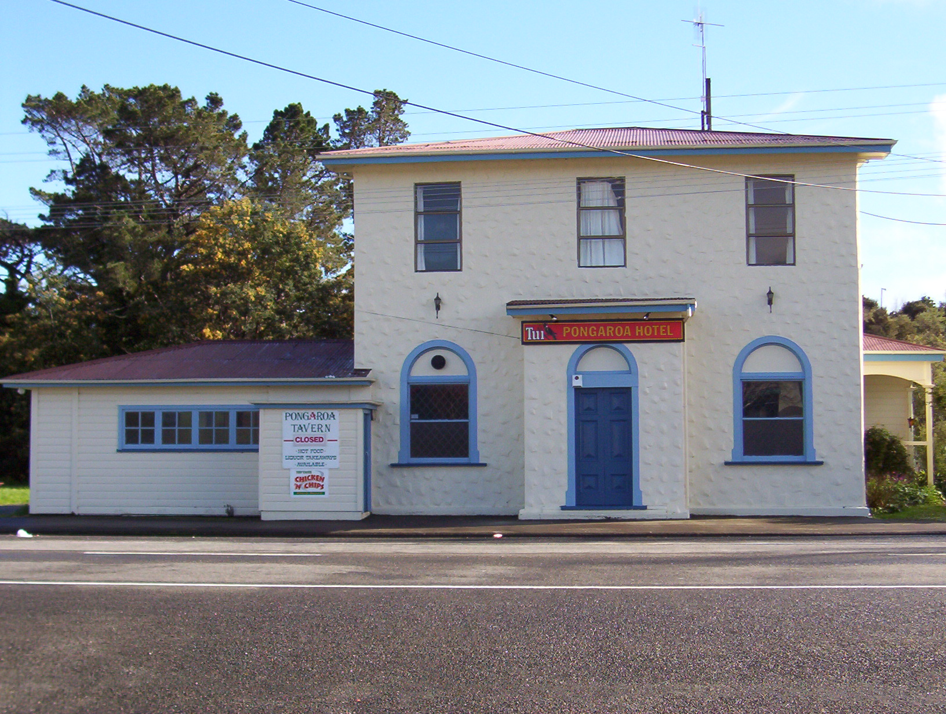
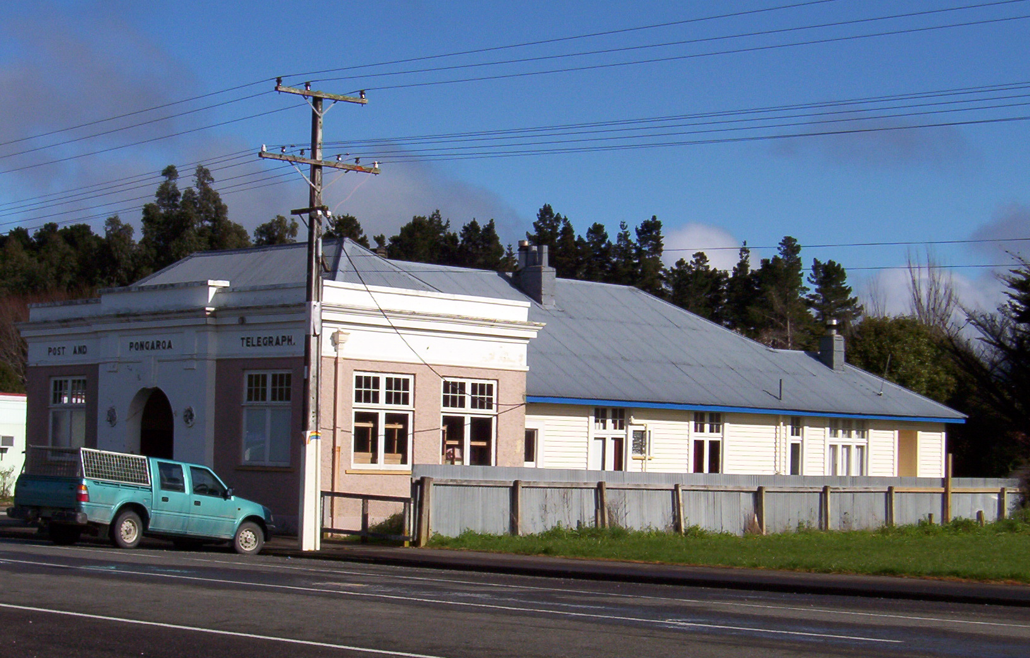
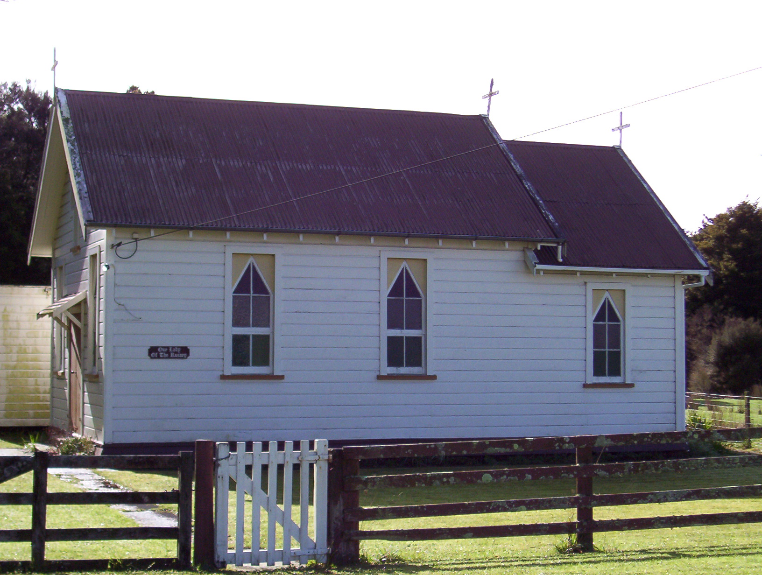
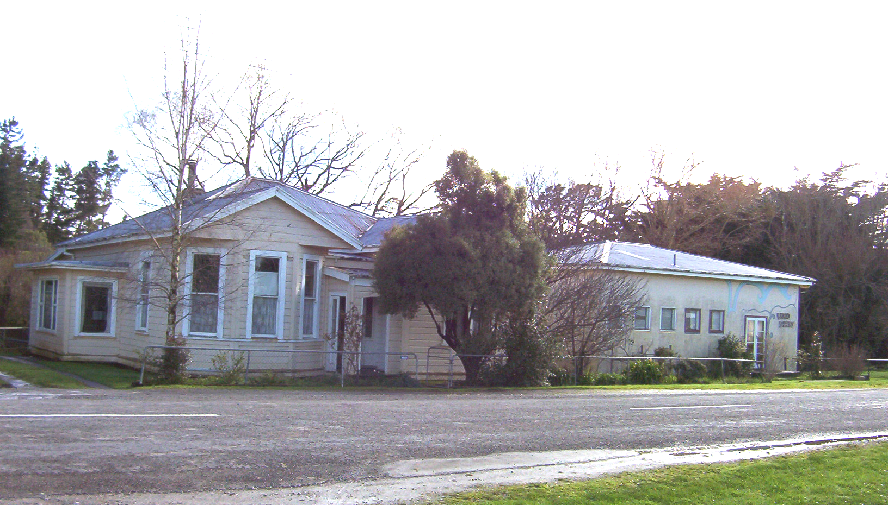
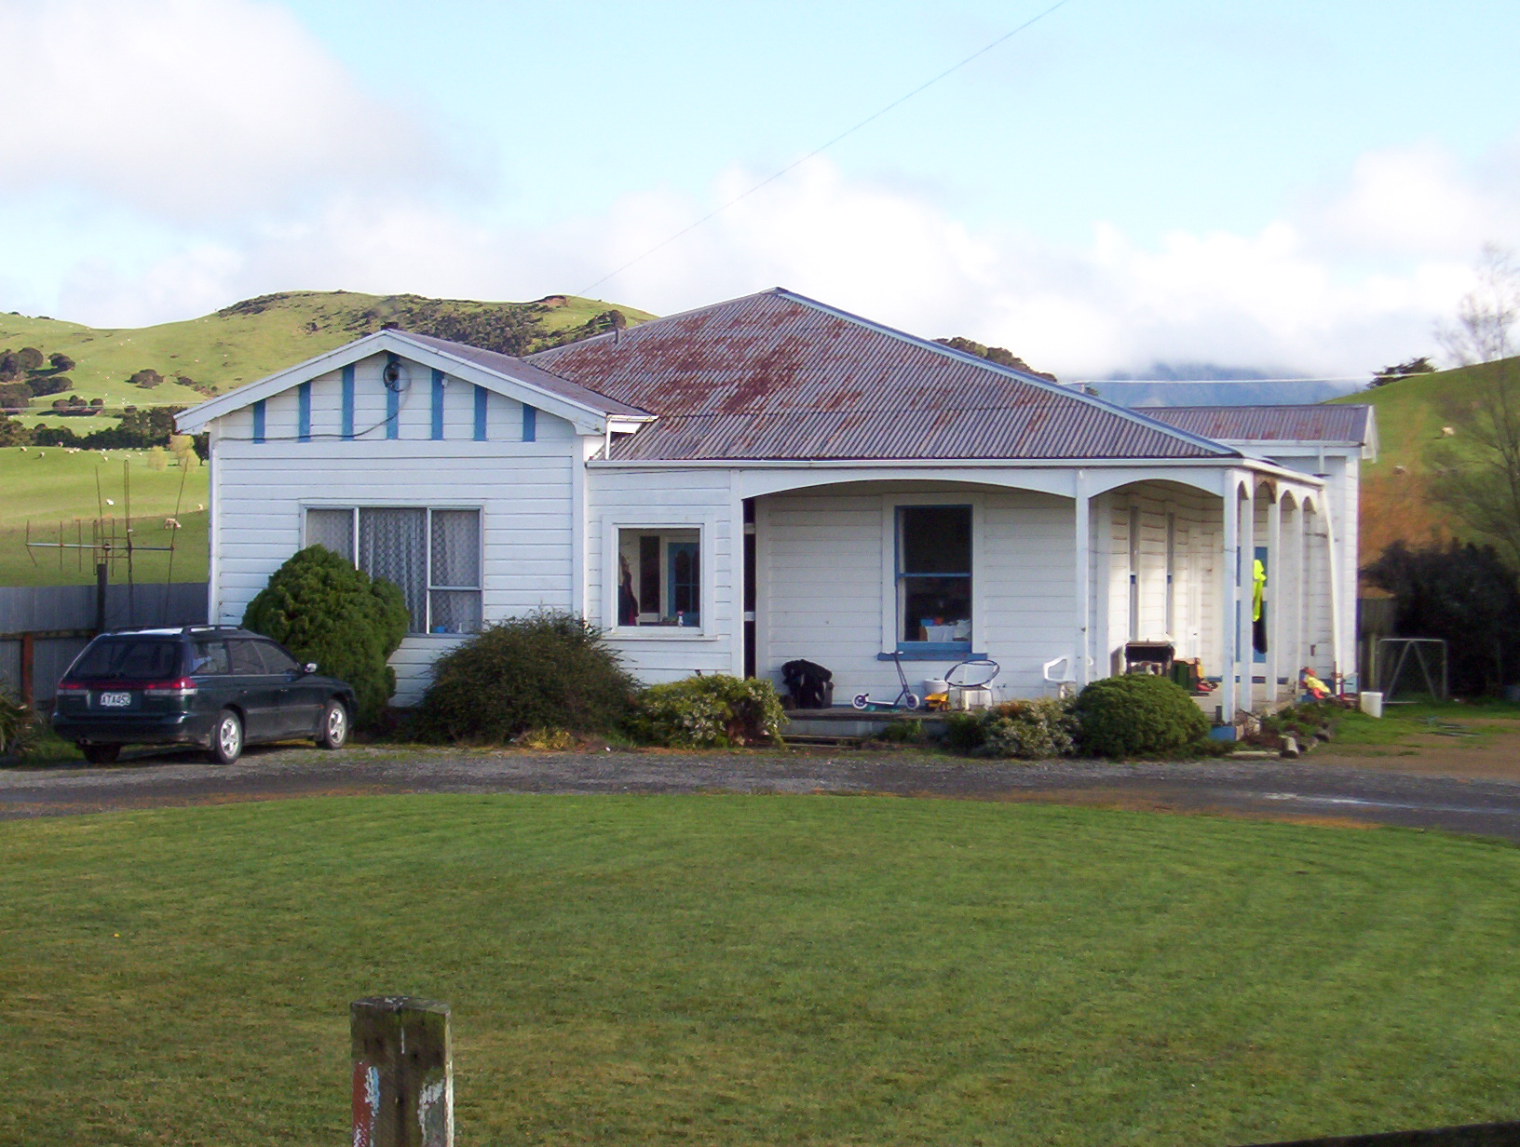
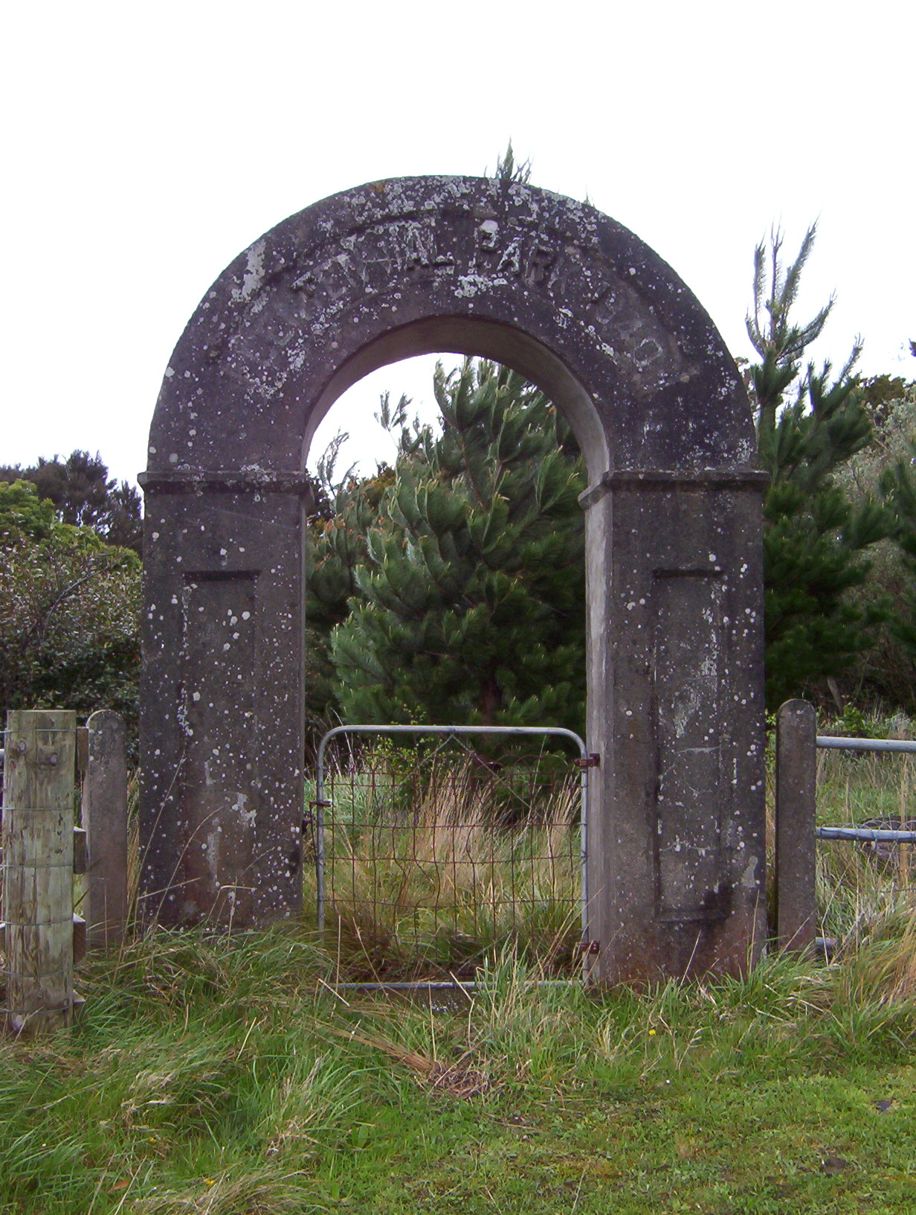
A Pongaroa Town Hall Co was formed by settlers in early 1900’s to build a hall. Many settlers held shares in the building which was used for many purposes including Saturday night movies for a lot of years. When the new hall was built, it became the RSA hall and later Te Kohango Reo (1985-2000).
This shed was once a classroom at the old school.

Community Centre built on the site of a brick kiln used in the early days, also as area popular with children for the “frog pond”. The hall was built in 1953 and later the War Memorial was shifted from the Domain to its present position in front of the hall. The hall also houses Rural Women (WDFF) and the library.
St John’s Church built 1905. Amalgamated with Presbyterians in 1970 to form a United congregation and had a resident vicar until 1983. It is now a Missionary district and the vicarage is privately owned.
Home of Akitio County Council from 1936 until amalgamation with Dannevirke County Council in 1976. The building now belongs to the Pongaroa Craft Group and is also used by the Public Health Nurse and the Historic Society.
F.F Tuckers grocery and hardware store, later owned by Percy Kent until about 1946. It had a number of owners prior to closing and is now used as Akitio Fisheries workshop. Maurice Wilkins was born here.
Built 1902, the Davies family opened their store in 1904 selling everything from gumboots to china. A bootmaker used part of the building at the time. The shop closed in the 1960’s. In recent years part of the building has been the “Loaves and Fishes,” a coffee shop run by a local church committee. It is now privately owned.
Originally a wheelwright and blacksmith shop with stables and residence on site. It later became a garage. Burnt down 2005. The building opposite was a saddlers.
Masonic Lodge built in 1907. Used for its original purpose and at one time was used for dances and card evenings.
Our Lady of Rosary built 1932 and still used for worship.
Pongaroa Cottage Hospital established by the efforts of the local community. Converted to a maternity home in the 1930’s, a new wing was added in the 1960’s and closed in 1969. Now privately owned.
Doctor’s residence. Built in 1915, the first doctor to live here was Dr Edgar Wilkins (1915-1917) whose son Maurice, born 1916, won the Noble Prize for discovering D.N.A. Now privately owned.
A postal service began 14th August 1895 and the Post Office Savings Bank in 1900. This building opened in 1924. It is now privately owned and postal services are operated from the store.
Opened as BNZ on 1st November 1910 and closed on 6th May 1918 when the bank became an agency of Pahiatua. Was leased for housing until the Pongaroa Hotel opened July 1948. Became a tavern c1980.
Originally St Andrews Presbyterian Church built in 1906 at a cost of $300. When the church was amalgamated with the Anglicans in 1970 to form a United Congregation the building was taken over by Playcentre. Today it is owned by the Pongaroa Playgroup Inc.
i
TO DANNEVIRKE

TO

PAHI
ATUA
PONGAROA’S HERITAGE WALK
MAKOMAKO
ST
AKAROA

ST
TO DANNEVIRKE
TO MASTERTON
COAST

ROAD
URUPA ST
(To cemetery & bush walk)
To Domain
ROUTE 52
Centennial Park archway.
Built to commemorate 100 years of NZ settlement.

